Integration Tutorial by Apex Hours on YT:

# Basic of Integration in Salesforce | Day 8 Part 1

* Agenda:
* Integrating with Salesforce – Part 1
  + Web Communication Fundamentals
  + Message Exchange Formats – JSON & XML
  + Understanding REST
  + Performing Callouts to External Services
    - HTTP Request & HTTP Response
* Integrating with salesforce – Part 2
  + Understanding SOAP
  + External Service Call to Salesforce
  + Salesforce VS Apex REST
  + SOAP call-ins using web methods
  + WSDL – Enterprise & partner
* Why Integration?
  + We have platform like salesforce, mobile, laptop etc and everything is connected so, we do some form of communication between difference platforms.

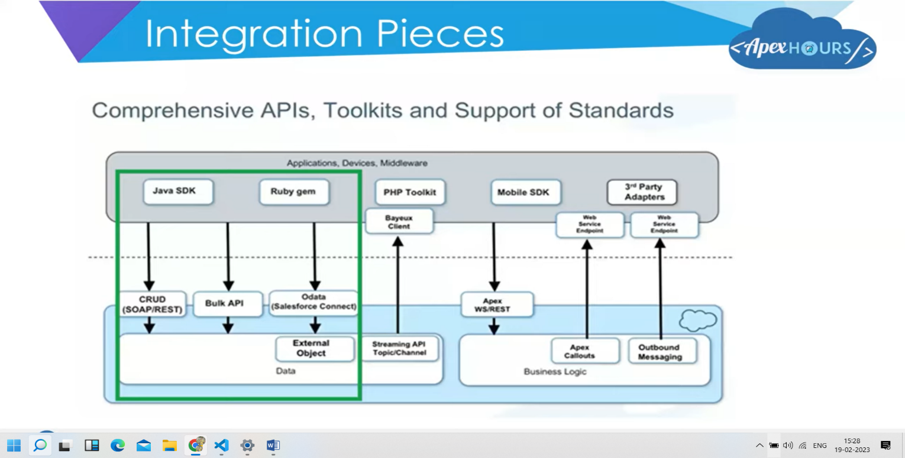

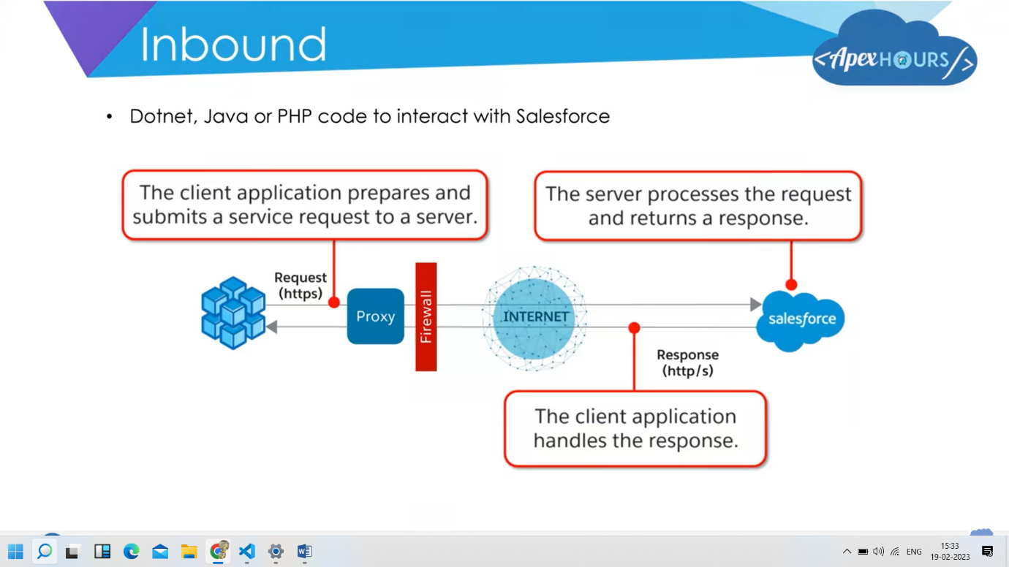

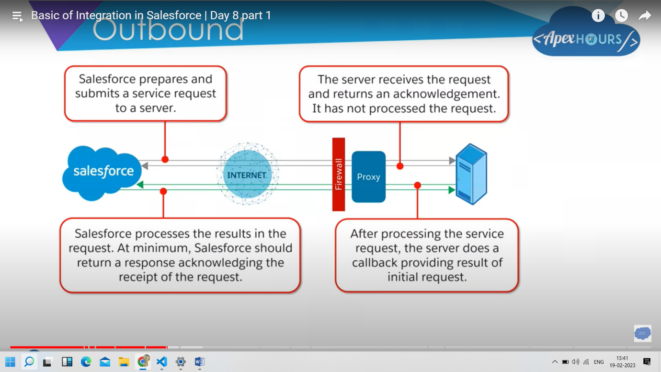

* Authentication: without authentication, we can’t connect and communicate with third party system.
  + User Authentication
    - Username/Password
    - Password never expires for API User
    - Profiles based restrictions
    - API Only user
    - Limits on number of failed attempts
  + Authorization – OAuth 2.0
  + Data Security –
    - How is access to data regulated?
  + Network Authentication –
    - Login hours and IP ranges
    - Org Wide trusted IP Address List
    - Security token for login via API or client outside white – listed IP ranges
  + Make sure the profile of the integration user meets the needs.
* Authentication –
  + Apex ignores security
  + Session timeouts
  + Transport security
    - SSL provides secure transport over HTTPs
  + Outbound
    - Two-way SSL
    - Port Restrictions
      * Port 80, 443, 1024-66535
    - Remote Site Settings
      * Sites which can be invoked from salesforce
* Basics of JSON –
  + JSON Stands for “JavaScript Object Notation”.
  + Recommended for devices with low processing power or slow internet.
  + It is language independent representation of objects.
  + Text based, human readable data exchange format.
  + Parsers available in many languages.
  + JSON can be transmitted over http/https

{

“FirstName”: “Apex”,

“LastName”: “Hours”

